KS2 Geography Knowledge Organiser: Mountains
Year 5

Background understanding for teachers and parents
Mountains are areas of land that are much higher than the land surrounding them. They are higher and usually steeper than a hill and are generally over 600 metres high. They are often found together in a group called a mountain range.
The highest mountain ranges are created by tectonic plates pushing together and forcing the ground up where they meet. Tectonic plates are also at work under the Atlantic Ocean, but instead of forcing the ground up, the two plates in the middle of the Atlantic Ocean are actually moving apart in opposite directions. This causes lava to erupt out of the gap that is left. As it cools down, the lava creates a long line of mountains. Other mountains - usually those that stand on their own - are created by ancient volcanoes eruption was so violent that it caved in on itself.

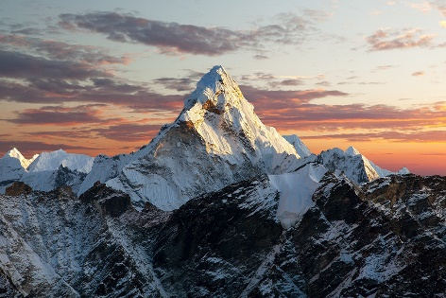
What? (Key Vocabulary)
Altitude | The height above sea level
Avalanche | A large amount of snow that quickly moves down a mountain or slope
Crust | The outermost layer of the earth
Gorges | A narrow valley with steep walls, found between hills and mountains
Summit | The highest point of a mountain
Tectonic plate | Pieces of the earth’s crust connected together
Where? (Key areas to learn about)
Mount Snowdon | Wales, United Kingdom, Europe  1,085 metres
Ben Nevis | Scotland, United Kingdom, Europe  1,345 metres
Scafell Pike | England, United Kingdom, Europe  978 metres
Slieve Donard | Northern Ireland, United Kingdom, Europe  850 metres
Mount Kilimanjaro | Africa  5,895 metres
Mount Everest | Himalayas, Asia  8,484 metres
Mount Aconcagua | Andes, South America  6,962 metres
Denali (Mt. McKinley) | Alaska Range, North America  6, 140m

Key Facts
Mountains are a natural part of the landscape with steep slopes.
They rise above 300m and have a summit of at least 600m.
Some mountains are found in groups called a mountain range but some mountains can be on their own. Not all mountains are single summit.
Mount Everest is the highest mountain above sea level in the world – 8848m.

Impact (on us at St Joseph the Worker)
Manchester is lucky to be near to the Pennines and fairly close to the Cumbrian mountains as well as the Lake District and its beautiful landscape.

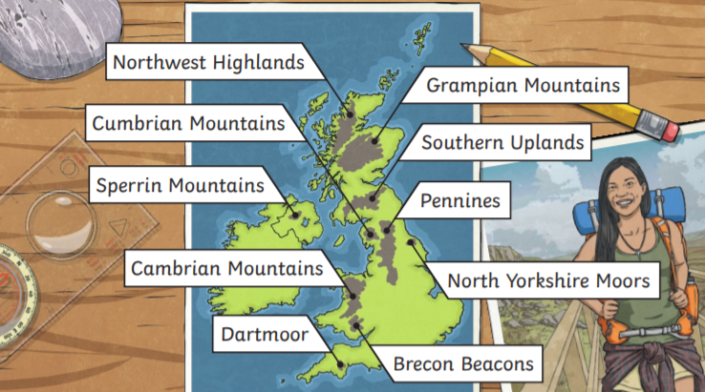
Kahoot Quiz Scores
Pre Assessment | Post Assessment

