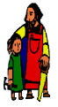
KS2 Geography Knowledge Organiser: Volcanoes and Earthquakes
Year 4

Background understanding for teachers and parents
A volcano is an opening in the Earth’s crust that allows magma, hot ash and gases to escape. Volcanoes can look like mountains or small hills, depending on what type they are. As plates carry on moving in different directions over long periods of time, friction causes energy to build up. Eventually it becomes so great that the energy is released, which creates a shock wave - an earthquake. If the earthquake is beneath the ocean it can create a series of huge waves, called a tsunami.
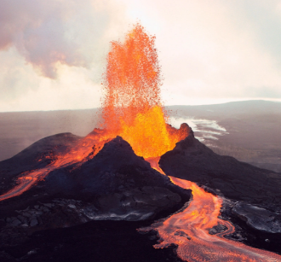

What? (Key Vocabulary)
Volcano | An opening or rupture in the Earth’s crust through which lava, ash and gases escape.
Magma | A molten substance beneath the Earth’s crust.
Crater | The mouth of a volcano.
Lava | Molten, hot rock flowing form a volcano.
Earthquake | A violent movement of parts of the Earth’s surface.
Epicentre | The point on the Earth’s surface at the centre of an Earthquake.
Tectonic plate | Pieces of the earth’s crust connected together
Richter Scale | Scale used to measure the magnitude of earthquakes
Where? (Key areas to learn about)
Mount Vesuvius | Near Naples, Italy, Europe
Krakatoa | Indonesia, Asia
Mount St Helens | Washington, USA, North America
Mount Tambora | Indonesia, Asia
Mauna Loa | Hawaii, North America
Eyjafjallajokull | Iceland, Europe
Mount Pelee | Martinique, North America

Key Facts
Extinct volcanoes aren’t expected to erupt again.
Dormant volcanoes haven’t erupted in the last 10,000 years but may erupt one day again. Parts of Edinburgh are a dormant volcano.
Most earthquakes occur near the tectonic plate boundaries.
Earthquakes can cause lots of damage to roads, buildings and property.
Pompeii was a famous Roman city destroyed by a volcano called Mount Vesuvius in 79 AD

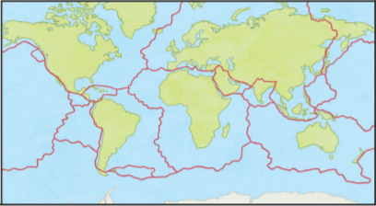

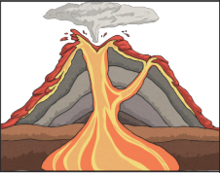
Kahoot Quiz Scores
Pre Assessment | Post Assessment

