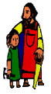
KS2 Geography Knowledge Organiser: UK Cities
Year 3

Background understanding for teachers and parents
- I can use the eight compass points to describe the location of the countries and cities of the UK.
- I can name and locate the main rivers and seas of the UK
- I can name and locate some of the counties of the UK
- I can use a map or atlas to locate areas of high ground in the UK.
- I can explain the importance of the Prime Meridian to England’s history.
- I can describe and understand how the UK has changed over time.
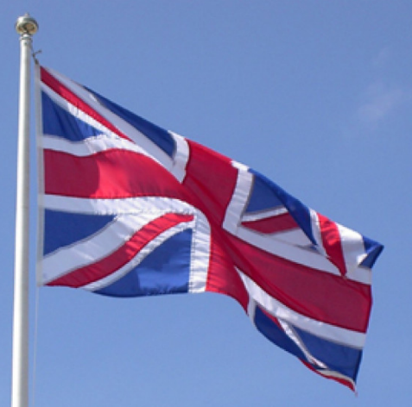

Where? (Key areas to learn about)
England | Capital City: London  Key River: Thames  Key Landmark: Stonehenge
Scotland | Capital City: Edinburgh  Key River: Tay  Key Landmark: Ben Nevis
Wales | Capital City: Cardiff  Key River: Severn (also flows through England)  Key Landmark: Snowdon
Northern Ireland | Capital City: Belfast  Key River: Bann  Key Landmark: Giants Causeway
Greater Manchester | A county in the UK which includes the town of Irlam and city of Salford
Lancashire | A county in the UK which includes the city of Bolton.
What? (Key Vocabulary)
County | A small area of the UK containing lots of towns and villages.
Prime Meridian | An imaginary line which divides the Earth into the eastern and western hemispheres.
Immigration | People moving to another country to live there permanently.
Landmark | A narrow valley with steep walls, found between hills and mountains
Great Britain | England, Scotland and Wales.

Key Facts
Local Governments control the local areas of counties and their services. These services include: Education, Transport, Policing, Public Safety, Social Care.
The Prime Meridian is an imaginary line which runs through the Royal Observatory in Greenwich. It is also used as the basis for the world’s time zones.
Many people decide to move to and live permanently in the UK. They might decide to live in the UK to be nearer to family, for work or for a different lifestyle.

Impact (on us at St Joseph the Worker)
The city of Salford and the town of Irlam fall within the county of Greater Manchester. Interestingly, Irlam used to be classed as part of Lancashire but was changed in the 1970s.

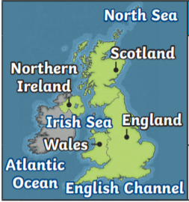
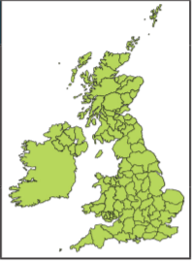

Kahoot Quiz Scores
Pre Assessment | Post Assessment

