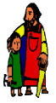
KS2 Geography Knowledge Organiser: Our Extreme World
Year 6

Background understanding for teachers and parents
Biomes are areas of our planet with similar climates, landscapes, animals and plants. What lives in each biome depends on:
- how warm or cold it is
- how dry or wet it is
- how fertile the soil is
The animals in a biome depend upon plants for food. The plants in a biome often also depend upon the animals for spreading pollen and seeds so that new plants can grow. So both plants and animals rely on each other to stay alive.
Throughout the study of this area we aim to widen the children’s understanding and curiosity about the world around them.

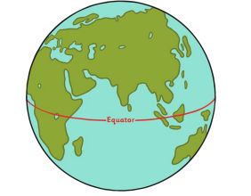

What? (Key Vocabulary)
Climate | The weather conditions in an area over time
Biome | An area with similar plants and animals
Equator | An imaginary line around the middle of the planet, dividing it into Northern and Southern hemispheres.
Vegetation belt | Smaller regions indicating where vegetation grows
Continent | A large solid area of land
Tundra | A flat cold treeless area
Where? (Key areas to learn about)
Rainforest | Hot and wet all year.  Rich in plants and animals. Poor soils.  Amazon Rainforest, South America
Savannah | Within the tropics.  Hot with a wet and dry season.  Mainly grass and a few specially adapted trees.  African Savannah, Africa
Desert | Can be hot or cold.  Limited plants.  13 deserts in China, Asia
Grassland | Warm summer and very cold winter.  Quite low rainfall.  Mainly grassland vegetation.  Australia, Oceania
Deciduous Forest | Cool summers and mild winters.  Rain throughout the year. Rich deciduous woodland.  UK, Europe
Tundra | Below freezing for most of the year.  Ground permanently frozen  Alaska, North America

Key Facts
The weather changes in different parts of the world. Where there are similar weather patterns this is known as a climate.
At the top of the Earth there is an arctic climate and some of the coldest temperatures in the world are found here
Temperate climates are found a bit further south, and as you approach the equator you find Mediterranean and desert climates. Some of the hottest places on Earth are found here, and few people live in this climate.
At the equator there is a tropical climate, and travelling south of the equator it gets cooler again before reaching the Antarctic.

Impact (on us at St Joseph the Worker)
Britain has a mild climate. It is in the temperate climatic zone and the sea affects the weather.
Great Britain is overall a Temperate Deciduous Forest biome and has many native species.

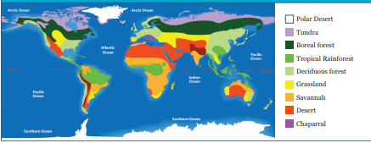
Kahoot Quiz Scores
Pre Assessment | Post Assessment

