ST JOSEPH THE WORKER RC PRIMARY SCHOOL

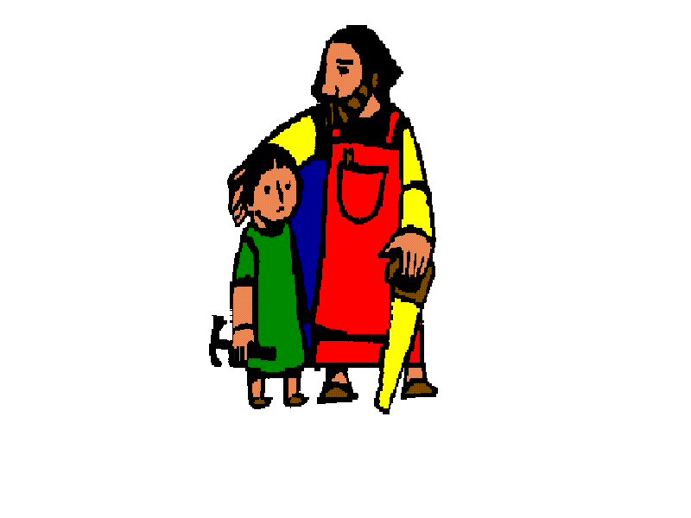

Child Friendly Safeguarding

policy

May 2016

Child Friendly Safeguarding Policy.

Mission Statement

Together as God’s children we will learn, love, grow, inspire. Let your light shine!

What is Child Safeguarding?

All of the adults around you think that your health, safety and welfare are very important.
At St Joseph the Worker we respect all children and we want to keep you safe and protect your rights.
We do our best to help all children make good educational progress.
We teach you how to recognise risks in different situations and how to protect yourself and keep safe.

How are children protected at St Joseph the Worker?

We provide a safe environment for children to learn in.
We help to ensure children remain safe at home as well as at school.
We think it is important for our children to know where to get help if they are worried or unhappy about
something.

If you need to talk what can you do?
- You can talk to any adult in school.
- You can talk to a Peer Supporter.
- You can write a message and put it in your class worry box for your teacher to see..
- Talk to a child from the Chaplaincy Team.
- Talk to trusted people that you know eg friends and family.
- Ring childline.
Don’t keep it a secret if ..........
- You are being bullied.
- If people are upsetting you or calling you names.
- If someone is hurting you.
- You think that you are experiencing child abuse.
- If someone who you don’t know asks you for your personal details eg where you live, your telephone number or asks you what your name is.
REMEMBER SOMEONE WILL ALWAYS LISTEN.

