KS2 Geography Knowledge Organiser: Rivers
Year 4

Background understanding for teachers and parents
A river is a moving body of water that flows from its source on high ground, across land, and then into another body of water, which could be a lake, the sea, an ocean or even another river.
A river flows along a channel with banks on both sides and a bed at the bottom. If there is lots of rainfall, or snow or ice melting, rivers often rise over the top of their banks and begin to flow onto the floodplains at either side.

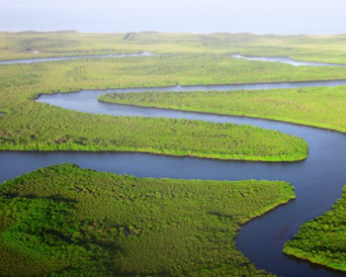

Where? (Key areas to learn about)
River Irwell | Europe, UK, 63 km
River Mersey | Europe, UK, 110 km
River Medlock | Europe, UK, 16 km
River Thames | Europe, UK, 346 km
River Nile | Africa, Egypt and Sudan, 6650 km
Amazon River | South America, 6400 km
Mississippi River | North America, 3766km
What? (Key Vocabulary)
Channel | The course in the ground that a river or water flows through.
Dam | A barrier built to hold back water.
Deposition/desposit | When rocks and other materials that have been eroded are dropped off further along the river.
Erosion | Rocks and other river materials are picked up by the water and moved to another place along the river.
Mouth | The point where a river joins the sea.
Source | The placer where a river begins.

Key Facts
Rivers usually begin in upland areas, when rain falls on high ground and begins to flow downhill.
Rivers have sources, channels, tributaries and mouths.
Rivers run through every continent in the world except Antarctica.
Most cities are located near rivers for many reasons including fishing, transport, waste disposal and communication.
Some rivers join up with other rivers (tributaries). The point where they meet is called a confluence.

Impact (on us at St Joseph the Worker)
Irlam is situated close to the river Irwell and this river provides the inspiration for the name of this town.
River’s and Canal’s played a central role in the development and growth of Irlam as an Industrial town.

Kahoot Quiz Scores
Pre Assessment | Post Assessment
